Automobile Ownership Presentation
Student’s Name
Institution Affiliation

Automotive Ownership Presentation
To begin with, I will outline the five biggest mistakes that many consumers make when buying a car. First, choosing the wrong vehicle is the first mistake since most of them do not consider purchasing a vehicle that meets one specific goal. The mistakes begin at the step where one fails to specify the single objective of buying a car. Each individuals planning to buy a car should begin by determining the objective of the car which will help them to identify which type of car to purchase. Secondly, individuals purchasing a car fails to take into consideration other costs involved in ownership of a car including maintenance and insurance costs. Most of them fail to understand that other costs such as insurance premium costs are proportional to the value of the car that is the more the value of the car, the more the premium costs. Thirdly, some individuals purchasing a car do not have the cash to purchase the car at once hence think about making payments on a monthly basis. The mistake they do is that they put no consideration on how much more the consumer will pay in the long run as compared to the car marked price. Making a consideration of either to buy a new car or an old car is the other mistake most individuals thinking of buying a car make. Since vehicles depreciate very fast, it is advisable that one considers buying a year or two old cars instead of purchasing a new car. This is because the individuals selling the second-hand vehicle will take 40% of the depreciation. Individuals should consider buying a slightly used car rather than a new car since current cars lack warrant. Lastly, individuals make a mistake of putting $0. An individual can be able to buy a new car with no money down. They need to understand that the value of the loan they take to purchase a new car will always be higher than the exact value of the vehicle.
Next, I do consider the following three statements; namely, it is smart to buy a car for $0 down, when considering a vehicle, the cost of the car is the only financial consideration, and A new vehicle is a wiser investment financially than a 2-year-old all to be a force.
Next, down payment, monthly payment, the life of a loan, Y-intercept and slope are the common terms used in automotive ownership. Down payment refers to the initial amount of money that an individual pays at the time he or she buys something on credit such as a car. The monthly payment, on the other hand, refers to the amount a borrower is required to pay monthly until the debt is paid off. The monthly payments are determined by the amount of the loan and are usually determined that is calculated when the credit is being issued. Life of a loan is the time that is taken to pay the loan before the loan is trucked. The y-intercept is a point on a straight line graph where a line vertically cuts the y-axis. Lastly, the slope is a steepness of the line in a graph which is the ratio of change in y-axis to the change in the x-axis.
I prefer purchasing 2018 Nissan Sentra S worth manual transmission which from my intensive research have found that the manufacturer is suggesting a retail price of about $18,000. However, I would prefer to purchase it from an individual who has used it for not more than three months to save on the buying cost but get the similar services with those I could have acquired from a new car. With the cost of the vehicle being $18,000, I prefer to pay first pay a 10% down payment that is $1,800 clearing the remaining amount on a monthly basis (borrowed amount) which is $16,200 with a monthly payment of $337.50 enabling me to clear the amount within 48 months.
Table 1 below displays the number of months for repayment and the balance owned.

Table 1
Numbers of months | Balance owned (balance borrowed-number of months *monthly)
0 | $16200
1 | $15862.5
2 | $15525.0
3 | $15187.5
4 | $14850.0
20 | $9450.0
40 | $2700
45 | $1012.5
46 | $675
47 | $337.5
48 | 0

This table content can be precisely represented in a graph as shown below;
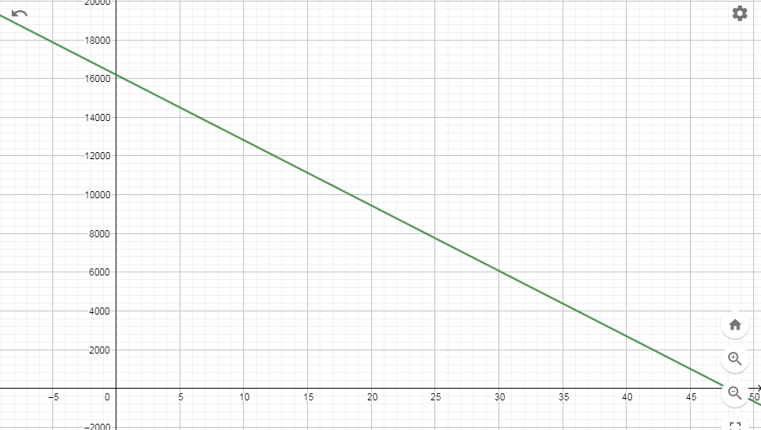
Figure 1
Figure 1 shown above is a straight line graph with the balance owned on the y-axis versus the number of months on the x-axis which slopes from left to right touching both the two-axis hence having a negative gradient. The time in months is the independent variable while the balance owned in dollars is the dependent variable.
I can calculate the gradient of the graph and determine the slope-intercept in the form of y=mx+b as follows;
Gradient = change in y/change in x
Taking two points, (0, 16200), (48, 0)
Slope = (0-16200)/ (48-0) =-337.5
Taking an arbitrary point (x, y) and (0, 16200)
(Y-16200)/(x-0) = -337.5
Simplifying, y = -337.5x + 16200
m=-337.5 slope
b= 16200 y-intercept
In this context, the y-intercept represents the balance borrowed while the slope represents the monthly payment. The slope of this graph is negative indicating that the balance owned proportionately decreases as time increases. The x-intercept is a representation of the life-of-loan.
If the above graph is translated three units up, the down payment is the one being changed making the y-intercept become $19,200 and the x-axis 57 months. The gradient of the graph does not change implying that the time for repayment increases proportionately with increase with the balance owned. This type of transition is referred to as a vertical shift. The new graph looks like the sketch below;
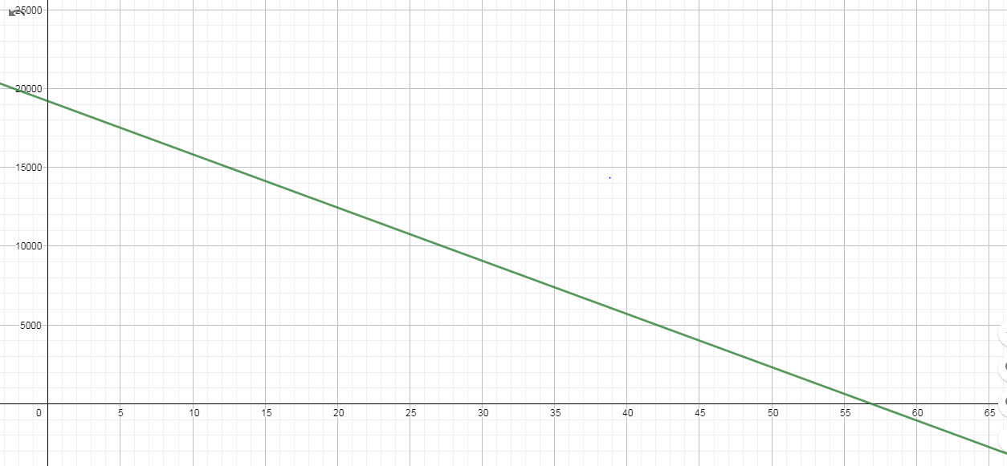
Figure 2
Doubling the slope on the original graph will also double the monthly payment. The equation for the new graph can be written as follow;
Y=-2mx +16200
Y=-675x+16200
The balance owned remains the same as in the original equation but the down payment changes (doubles) making the life-of-loan to half to 24 months. Cutting the slope of the original graph by 25%, the monthly payment is reduced by 25% to $253.125 which increases the life-of-loan to 64 months.

